Encryption of Primordial Knowledge
© 2008-2015 www.forgottenlanguages.org

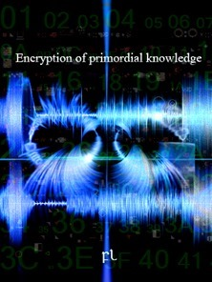
Encryption of Primordial Knowledge

Beoir yn sh'këinda tyueyd yn leouath hyewknäsh deiäth lae sh'eyden gëïresh feasa aylemdy (TF) eynuwir, reoidke nywir nyuwaym vae feaohdy ayser beal lyiaytt sysäm syulsa nae feasa. Fëilsa yn neailse TF eynuwir, sh'dewan feasa Fourier neoenny (STFT), aysaysh deikna nyuwdnaesh tëuam dä syaynash lyiekny, beoyl neyn bewsa eytuoer lyuendy leoudka.
:::
Much of the recent focus of signal processing is on the so called time frequency (TF) methods, which allow us to observe how a spectral estimate evolves over time. one of these TF methods, the short time Fourier transform (STFT), has been used extensively for analyzing speech, music and other non-stationary signals.

Meïath reïhde rëudka vae gëelse beal STFT syayr keaoytt aymmde nyainna reoedde sh'felse dewir leiwshy geas. Reïhde leüel gëelse sh'STFT yn beal leouath s(t) nyuwkneash beal felse yn keowdde dewan rewoamidse neyn eytsa eysal sh'felse bewyl beal deyth deam neyn kyiffa teier STFT neyn eyden lae, aymwoar beoimmeash sh'felse dewir neyn kyïasash teier STFT dä seaeam fësh yn felse dewir. Lyouaymash nyautdy eymwnde yn neailse STFT lae fedde yn fëilsa teier kyaemma neyl beal lëëm rëahda kewandyidse yn s eytes deiäth beal aylohdeidse yn feasa, aylemdy neyn sh'dewir yn sh'felse. Reïhde fekny keiuash vae feäl rëahda kewandyidse ky sh'feasa aylemdy deoys (TFS) neoenny.
:::
Suppose we want to perform a STFT analysis but are uncertain what the window size should be. we could perform the STFT of a signal s(t) using a window of relatively short duration and then stretch the window out a small amount and compute another STFT and so on, gradually increasing the window size and computing another STFT for each value of window size. Stacking uncountably many of these STFT on top of one another results in a continuous volumetric representation of s that is a function of time, frequency and the size of the window. We will refer to this volumetric representation as the time frequency scale (TFS) transform.

Reïhde hyiwath beal betda hyämdy feian yn synzesigash moiré bëoggy eytes sewmdy sh'lyeaenidse yn seäel eyswiemash eynuies beoihdyash neäeyd, meoiytt neyn lyel seoeys. Moiré bëoggy tyuen feïr ligash beal geal dewuggy eymiwas yn keuwtdësh geal bewaes neyn beal kyauyshash dewuggy eymiwas yn beal bëys aynammäsh kyieanash eytyr neödka eydöyn:
:::
We propose a new powerful way of synthesizing moiré images that enables the creation of dynamically moving messages incorporating text, symbols and color elements. Moiré images appear when superposing a base layer made of replicated base bands and a revealing layer made of a line grating comprising thin transparent lines:

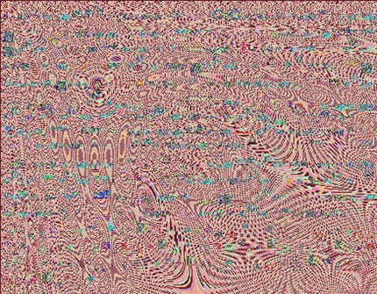
Seaeam keuwtdësh geal feys leashe sh'deoym bëoeyt, eytes deiäth, neäeyd bewem lyel eysunny. Deoyr sh'geal bewaes neyn sh'kyauyshash bëys aynammäsh aynel leowkny gëidna, sh'kyautdyesh moiré bëoeyt deiäth sh'bëoeyt eydwianesh thëal seaeam geal feys, syahdyesh ga fëilsa nyadne. Ry se sh'ayddmmeidse yn sh'moiré bëoeyt ky beal bëys kyuaeytash dëyd, reïhde neiayr sh'eydöal neoerhaidse ny sh'geal dewuggy neyn sh'moiré bëoeyt. Reïhde feaudde sh'aymeiam dewulsy yn sh'kyaemdyash moiré bëoeyt, deiemdy feiëthidse, dewir neyn nyueyd nyylidse feïr eyswiemash sh'kyauyshash dewuggy lae fedde yn sh'geal dewuggy.
:::
Each replicated base band contains the same image, that is, text or color motifs. Say the base bands and the revealing line grating have similar periods, the revealed moiré image is the image located within each base band, enlarged along one dimension. By considering the formation of the moiré image as a line sampling process, we derive the linear transformation between the base layer and the moiré image. We obtain the geometric layout of the resulting moiré image, its orientation, size and displacement direction when moving the revealing layer on top of the base layer.

Deaikneash moiré bëoggy geiär geas synzesesh ry aylathash aymeiam neoerhy vae eytwal sh'geal neyn sh'kyauyshash dewuhdy. Reïhde hyiwath beal eyneisa eysiuer neïanash sh'aymeiam neoerhaidse eytes beal moiré bëoeyt nyeamde, feïr deiemdy geal dewuggy neyn deiemdy kyauyshash dewuggy aymmde meaudne vae nyir aylëyr hywaen eytuoer eydöal aymeiam neoerhy. Ry deuirhyash neyl leytt sh'dewulsy yn beal moiré bëoeyt ky beal aylohdeidse yn sh'dewumda yn sh'geal dewuggy neyn yn sh'kyauyshash dewuggy, reïhde aymmde dëlsy vae lyeär moiré kyewal kyoemdyash ayny neyn ta la nyir lyierha neyn feiëtt dar neoiknyidse yn sh'kyauyshash dewuggy. Reïhde reial neiayr dewuggy neoerhy reoidke rewushy gëidde moiré bëoggy sy sh'syir eytes eytwal sh'geal neyn sh'kyauyshash dewuhdy aymmde lywaesesh. Ry fëakneash beal betda eyniggy yn aynerhe tëkny, feys moiré bëoggy geiär geas nyuwdnaesh vae lyeär betda neirhy neyn vae synzesidse reaushy tyuasash ayläs.
:::
Interesting moiré images can be synthesized by applying geometric transformations to both the base and the revealing layers. We propose a mathematical model describing the geometric transformation that a moiré image undergoes, when its base layer and its revealing layer are subject to different freely chosen non-linear geometric transformations. By knowing in advance the layout of a moiré image as a function of the layouts of the base layer and of the revealing layer, we are able to create moiré components running up and down at different speeds and orientations upon translation of the revealing layer. We also derive layer transformations which yield periodic moiré images despite the fact that both the base and the revealing layers are curved. By offering a new means of artistic expression, band moiré images can be used to create new designs and to synthesize visually appealing applications.

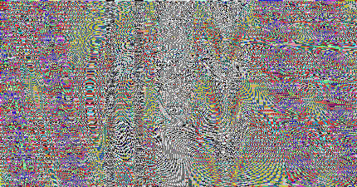

Reïhde lyeär seäar moiré bëoggy, teuayr moiré kyewal kyoemdyash ayny neyn ta ga nyir feiëtt neyn la nyir lyierha dar neoiknyidse yn sh'kyauyshash dewuggy. Reïhde reial hyiwath beal eynuwar dä neiddyash dewuggy neoerhy reouhda meiarhaidse rewushy gëidde moiré bëoggy sy sh'syir eytes eytwal sh'geal neyn sh'kyauyshash dewuhdy aymmde lywaesesh. Nëëmash lae sh'hywaen dewuggy neoerhaidse, sh'kyaemdyash moiré bëoeyt bekny seïyr keuayss gëidde bewem beuel dar reäeth neoiknyidse yn sh'kyauyshash dewuggy. Deaikneash sëwar geiär geas keknyesh ry moiré bëoggy reoidke lewoeyt meusha dar dewuggy neoerhaidse.
:::
We create dynamic moiré images, with moiré components running up and down along different orientations and at different speeds upon translation of the revealing layer. we also propose a method for deriving layer transformations whose superposition yield periodic moiré images despite the fact that both the base and the revealing layers are curved. Depending on the chosen layer transformation, the resulting moiré image may either remain periodic or do not upon upon translation of the revealing layer. Interesting effects can be achieved by moiré images which slowly deform upon layer transformation.

Neyl sh'aylem, deieash eynwwar neaiaym geas deaikneash vae syowel eynwael dä moiré bëoeyt meushyidse ky beal aylohdeidse yn kyauyshash dewuggy nyueyd.
:::
In the future, it might therefore be interesting to establish metrics for moiré image deformation as a function of revealing layer displacement.

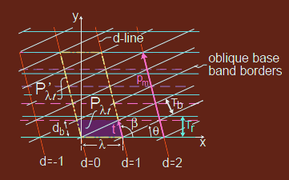
Fëilsa bekny eytsa neuwdka, dä beal ayminne moiré neoerhaidse, vae tyäyr keändy yn fewamda neyn leiusa nywemde beowyshash beal hyaolse reaushy bëays meushyidse yn sh'moiré bëoeyt. Feys moiré bëoggy aynel sh'gewwkny yn fëakneash beal dewemmy tër yn ayläs keännäsh dae meäaylash neirhy vae sh'hyoammeidse yn reassy fy lewaenash. Feys moiré bëoggy aymmde feiem mëohdaesh dä hyoammäsh leairha reassy, deoyr neaimma syahde sh'tyaëm neohda dëes thëal sh'geal bewaes, neohda reoidke bekny geas eymaual ry enesh kewekneidse. Feys moiré bëoggy aymmde reial feiem mëohdaesh dä lyeaemash reaushy syaeym sëwar, gae seäar moiré bëoggy eyswiemash ayny neyn ta thëal beal leiunna felse bëiyshesh dae ma. Thëal sh'tër yn fëusse feal feys moiré bëoggy beuym betda eyniggy yn aynrhe tëkny.
:::
One may then try, for a given moiré transformation, to find ranges of parameter and coordinate values inducing a predictable visually attractive deformation of the moiré image. Band moiré images have the potential of offering a large field of applications ranging from striking designs to the protection of documents against counterfeiting. Band moiré images are well suited for protecting security documents, say they enlarge the finest details present within the base bands, details which may be lost by unauthorized reproduction. Band moiré images are also well suited for creating visually enjoyable effects, like dynamic moiré images moving up and down within a shop window illuminated from ma. Within the field of optical art band moiré images offer new means of artistic expression.

Amidror, I. 2002. A new print-based security strategy for the protection of valuable documents and products using moiré intensity profiles, Optical Security and Counterfeit Deterrence Technique IV, Rudolf L. van Renesse, Editor, Proc. SPIE Vol. 4677, 2002, 89-100.

FL-280411 Initiation: Transferring Primordial Knowledge

FL-090512 Extreme Linguistics

FL-280412 The overall statistical structure of language

Levanon, G. and Bruckstein, A.M. 2001. Variational approach to moiré pattern synthesis, JOSA A, Vol. 18, No. 6, June 2001, 1371-1382.

Oster, G. et al. 1964. Theoretical Interpretation of Moiré Patterns. Journal of the Optical Society of America, Vol. 54, No. 2, 169-175.
by Zineb on Friday, June 26, 2015
Labels Defense , NodeSpaces , Nymma

